

**Project Report**

**TED SHOP**

# **Document description**

# **SRS overview**

## **2.1. List of system users**

1. Manager: The person uses the system to register information of product types, products, and staffs, and print summary reports.

2. Staff : The person uses the system to import and deliver products.

3. Customer: The person uses the system to order products.

## **2.2. List of use cases**

1. Register product types

2. Register products

3. Register staffs

4. Import products

5. Deliver products

6. Order products

7. Show summary reports

## **2.3. Use case diagram**

### **2.3.1. Preliminary use case diagram**

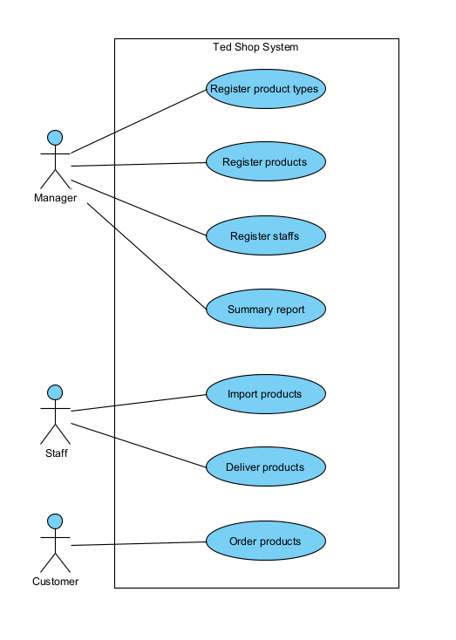

### **2.3.2. Use case detail diagrams**

#### ***2.3.2.1. Use case “Register product types”***

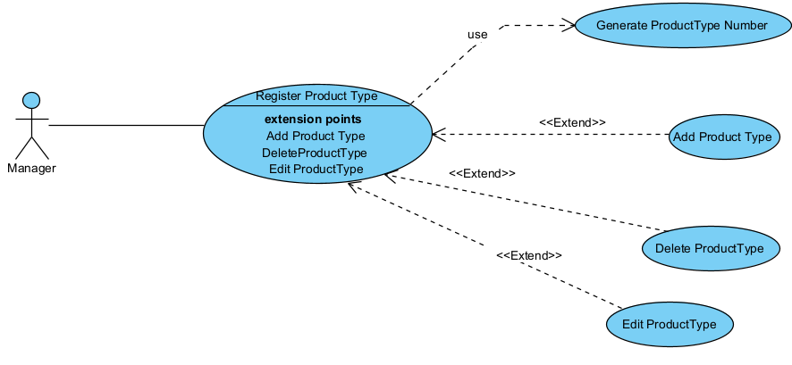

#### ***2.3.2.2. Use case “Register products”***

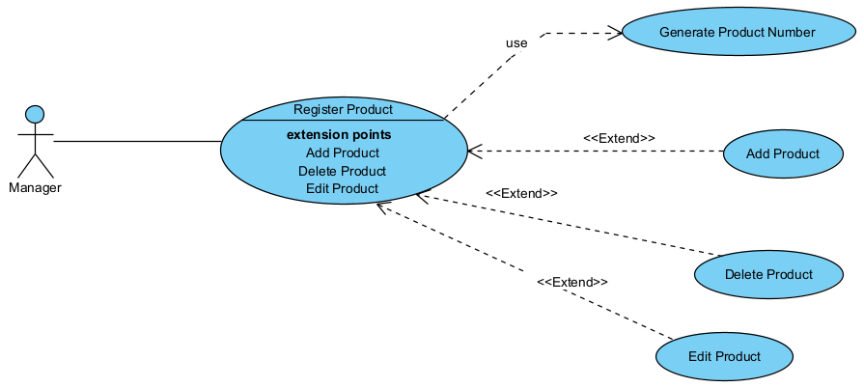

#### ***2.3.2.3. Use case “Register staffs”***

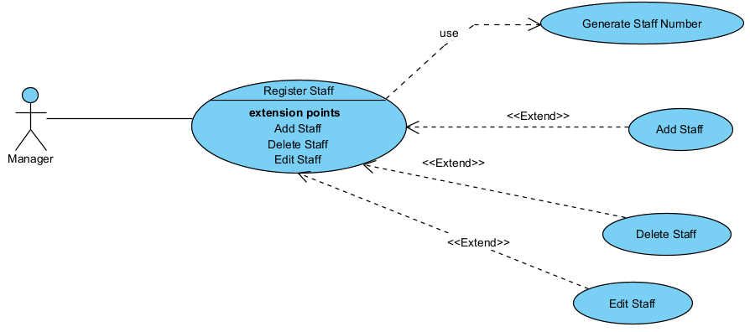

#### ***2.3.2.3. Use case “Import products”***

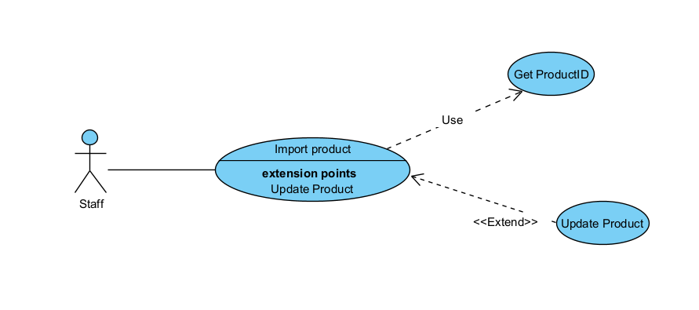

#### ***2.3.2.4. Use case “Deliver products”***

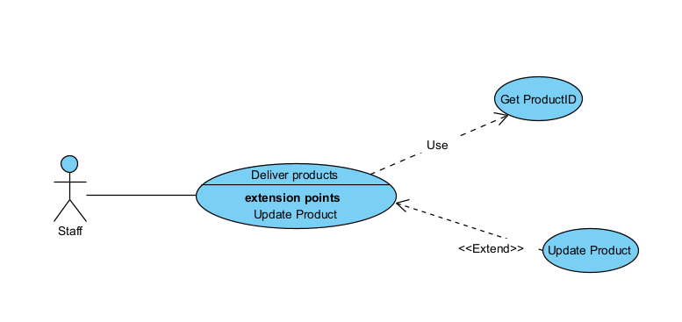

#### ***2.3.2.6. Use case “Order products”***

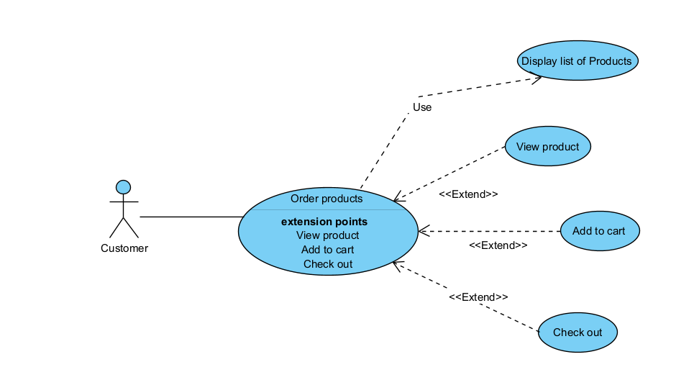

#### ***2.3.2.7. Use case “Show summary reports”***

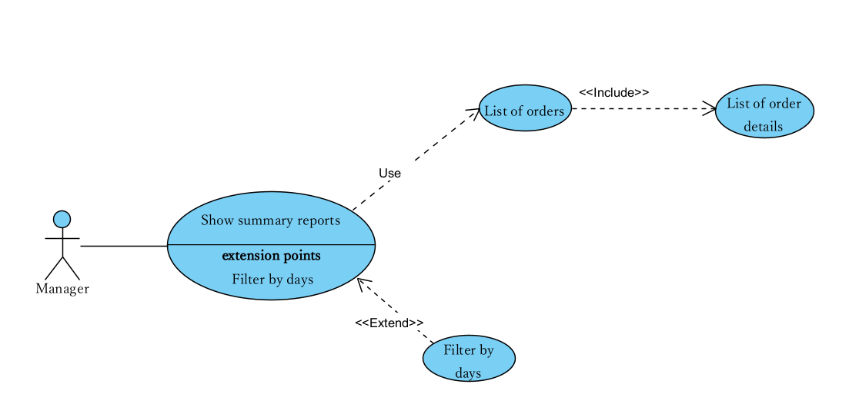

## **2.4. Activity diagrams of use case scenarios**

### 

### 

### **2.4.1. Activity diagram for use case “ Order products”**

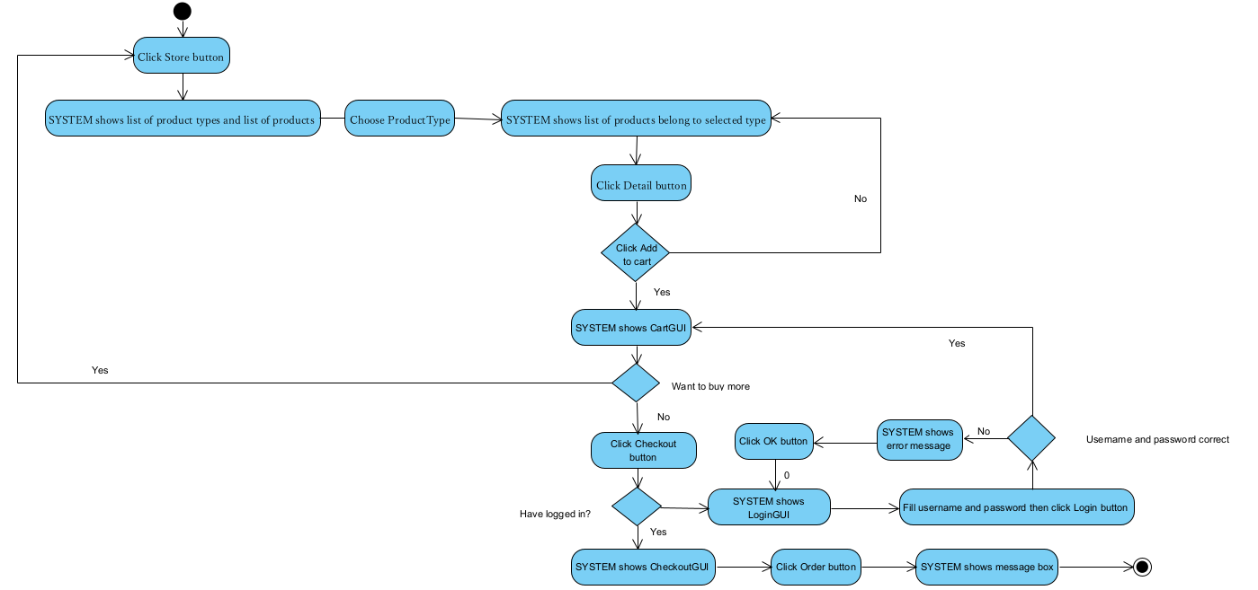

### **2.4.2. Activity diagram for use case “Register products”**

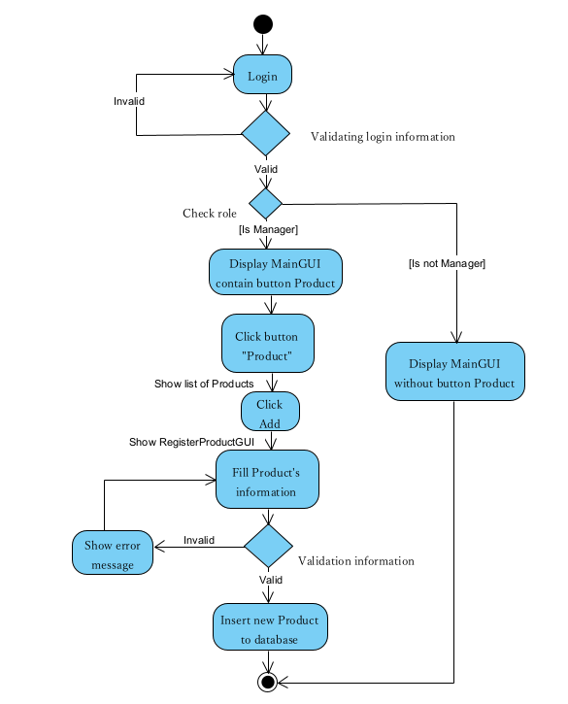

### **2.4.3. Activity diagram for use case “Register staffs”**

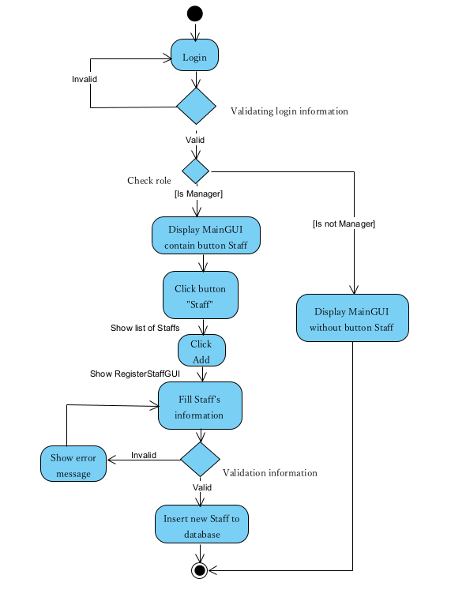

### **2.4.4. Activity diagram for use case “Import products”**

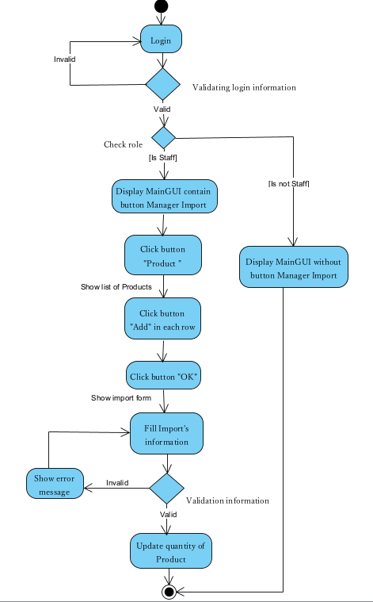

### **2.4.5. Activity diagram for use case “Deliver products”**

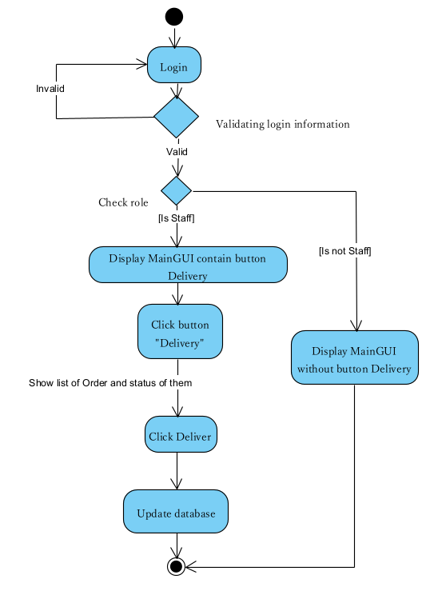

### **2.4.6. Activity diagram for use case “Register product types”**

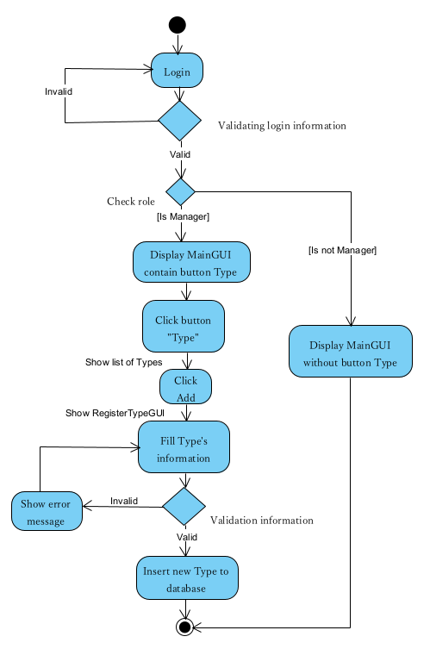

# **Data model**

## **3.1. Entity Relationship Diagram (**[**Link ERD**](https://drive.google.com/file/d/196ls3XH6orEPlHUm5EnRSrnowM4St_Wy/view?usp=sharing)**)**

### 

## **3.2. Table details**

Note: Attribute with underline is Primary key and Foreign key

### 

### **3.2.1. Table name: Staff**

| **Field name** | **Type** | **Size** | **Note** |
| --- | --- | --- | --- |
| StaffID | uniqueidentifier |  | Primary key |
| Name | String | 60 | Not null |
| Address | String | 255 | Not null |
| Phone | String | 20 | Not null |
| Account | String | 20 | Not null |
| Username | String | 25 | Foreign key, references Account(Username) |

### **3.2.2. Table name: Import**

| **Field name** | **Type** | **Size** | **Note** |
| --- | --- | --- | --- |
| Import_ID | uniqueidentifier |  | Primary key |
| StaffID | uniqueidentifier |  | Foreign key, references Room(RoomID) |
| Import_date | Date |  | Not null |

### **3.2.3. Table name: Customer**

| **Field name** | **Type** | **Size** | **Note** |
| --- | --- | --- | --- |
| CustomerID | uniqueidentifier |  | Primary key |
| Name | String | 60 | Not null |
| Address | String | 255 | Not null |
| Phone | String | 20 | Not null |
| Username | String | 25 | Foreign key, references Account(Username) |

### **3.2.4. Table name: ProductType**

| **Field name** | **Type** | **Size** | **Note** |
| --- | --- | --- | --- |
| TypeID | uniqueidentifier |  | Primary key |
| Type_name | String | 255 | Allow null |

### **3.2.5. Table name: Product**

| **Field name** | **Type** | **Size** | **Note** |
| --- | --- | --- | --- |
| ProductID | uniqueidentifier |  | Primary key |
| TypeID | uniqueidentifier |  | Foreign key, references ProductType(TypeID) |
| Produce_country | String | 50 | Not null |
| Name | String | 60 | Not null |
| Description | String | 255 | Allow null |
| User_guide | String | 255 | Allow null |
| Price | Double |  | Not null |
| Sell_price | Double |  | Not null |
| Quantity | Integer |  | Not null |

### **3.2.6. Table name: Import_detail**

| **Field name** | **Type** | **Size** | **Note** |
| --- | --- | --- | --- |
| Import_detail_ID | uniqueidentifier |  | Primary key |
| Import_ID | uniqueidentifier |  | Foreign key, references Imports(Import_ID) |
| ProductID | Integer |  | Foreign key, references Product(ProductID) |
| Quantity | Integer |  | Not null |

### **3.2.6. Table name: Order**

| **Field name** | **Type** | **Size** | **Note** |
| --- | --- | --- | --- |
| OrderID | uniqueidentifier |  | Primary key |
| CustomerID | uniqueidentifier |  | Foreign key, references Customer(CustomerID) |
| StaffID | uniqueidentifier |  | Foreign key, references Staff(StaffID) |
| Order_date | Date |  | Not null |
| Total_amount | Double |  | Not null |
| Deliver_date | Date |  | Allow null |

### **3.2.7. Table name: Order_detail**

| **Field name** | **Type** | **Size** | **Note** |
| --- | --- | --- | --- |
| Order_detail_ID | uniqueidentifier |  | Primary key |
| OrderID | uniqueidentifier |  | Foreign key, references Orders(OrderID) |
| ProductID | uniqueidentifier |  | Foreign key, references Product(ProductID) |
| Quantity | Integer |  | Not null |

### **3.2.7. Table name: Account**

| **Field name** | **Type** | **Size** | **Note** |
| --- | --- | --- | --- |
| Username | String | 25 | Primary key |
| Password | String | 20 | Not null |
| Role | String | 10 | Not null |

# **Class diagram**

## **4.1. Layers**

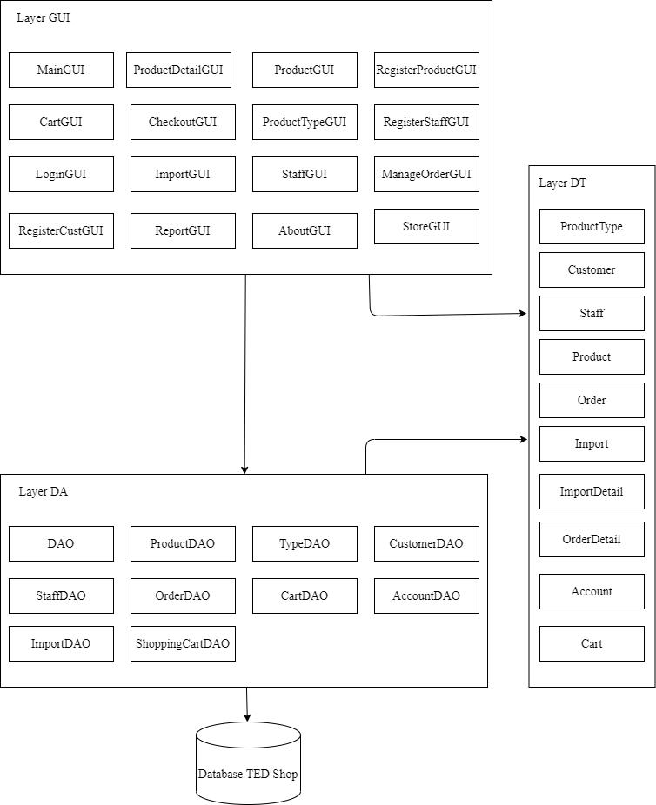

## **4.2. Modeling the Class Behaviors - sequence diagrams**

### **4.2.1. Sequence diagram for use case “Register product types”**

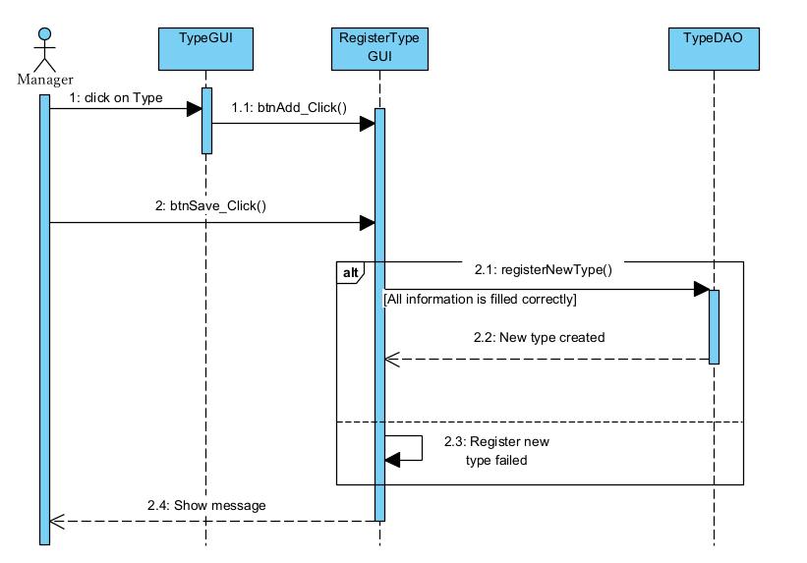

### **4.2.2. Sequence diagram for use case “Register products”**

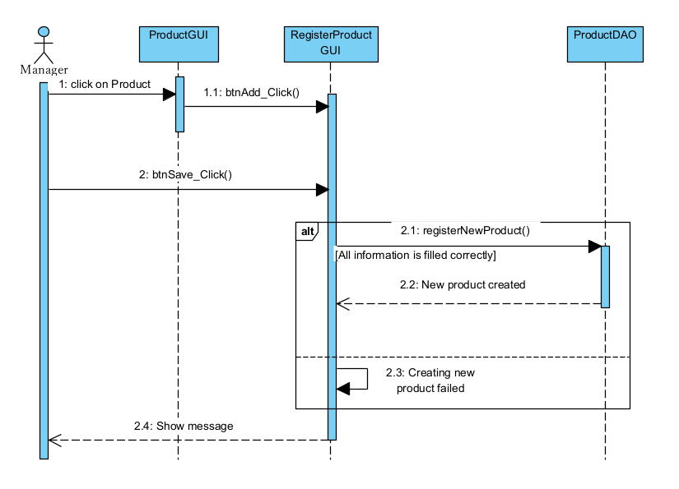

### **4.2.3. Sequence diagram for use case “Register staffs”**

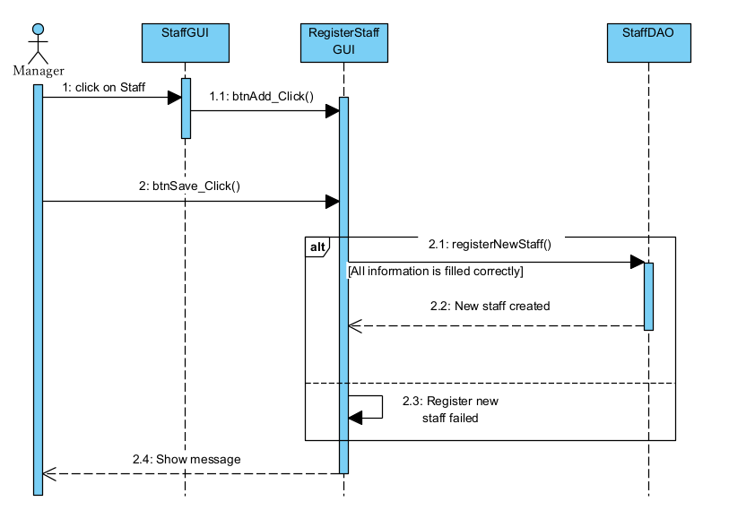

### **4.2.4. Sequence diagram for use case “Import products”**

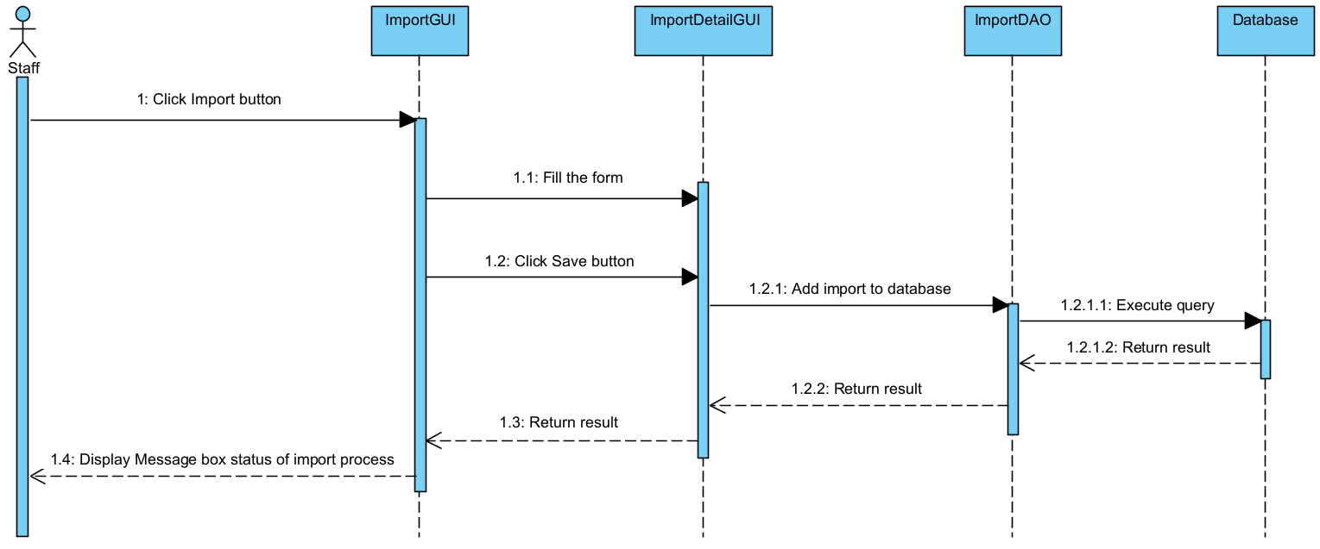

### **4.2.5. Sequence diagram for use case “Deliver products”**

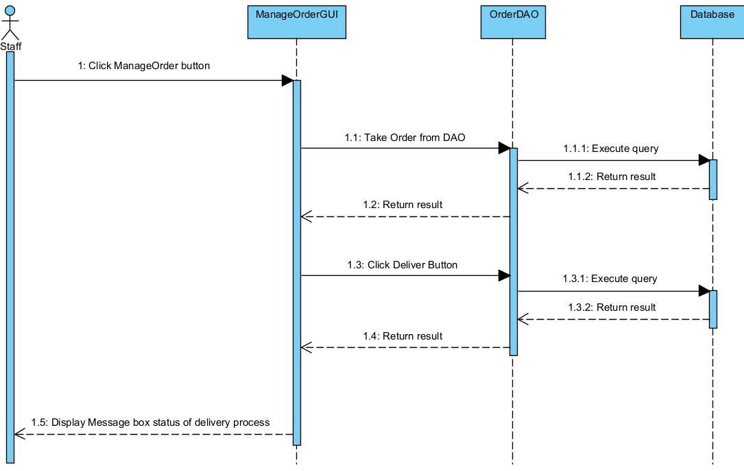

### 

# **User Interface Model Design**

## **5.1. User interface model design**

### **5.1.1. “Store” Screen**

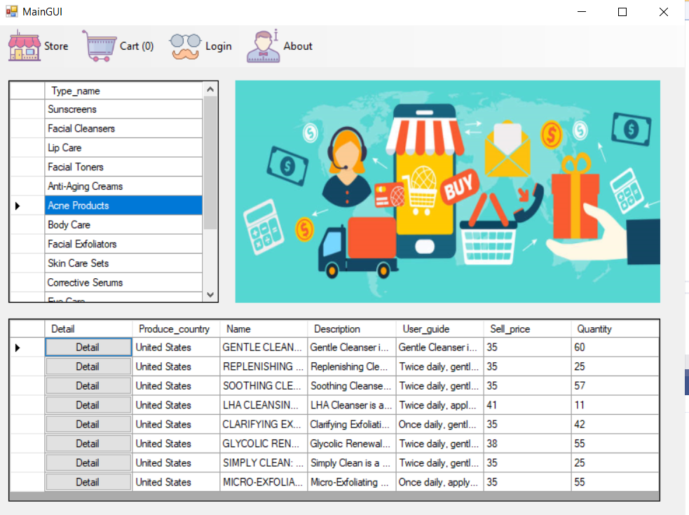

### **5.1.2. “Product detail” Screen:**

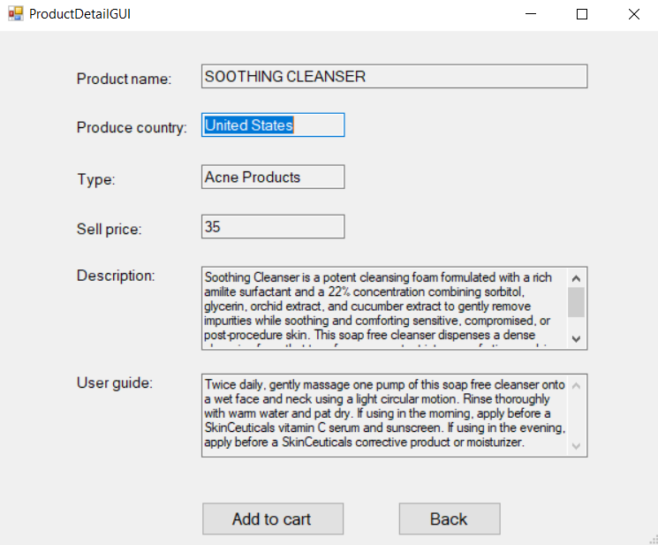

### **5.1.3. “Product” Screen:**

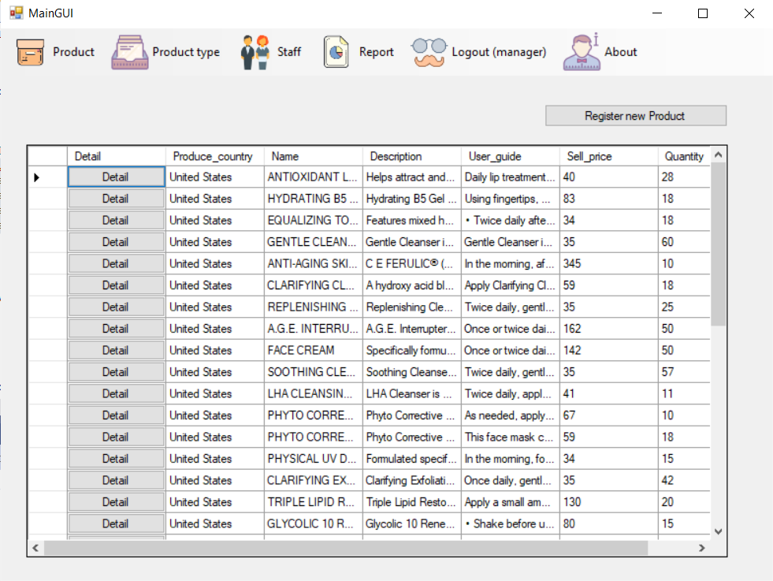

### **5.1.4. “Register product” Screen:**

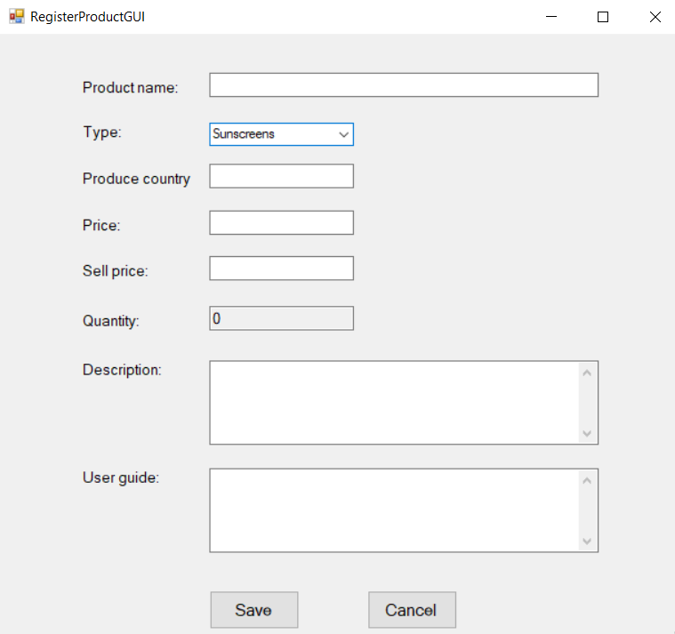

### **5.1.5. “Report” Screen:**

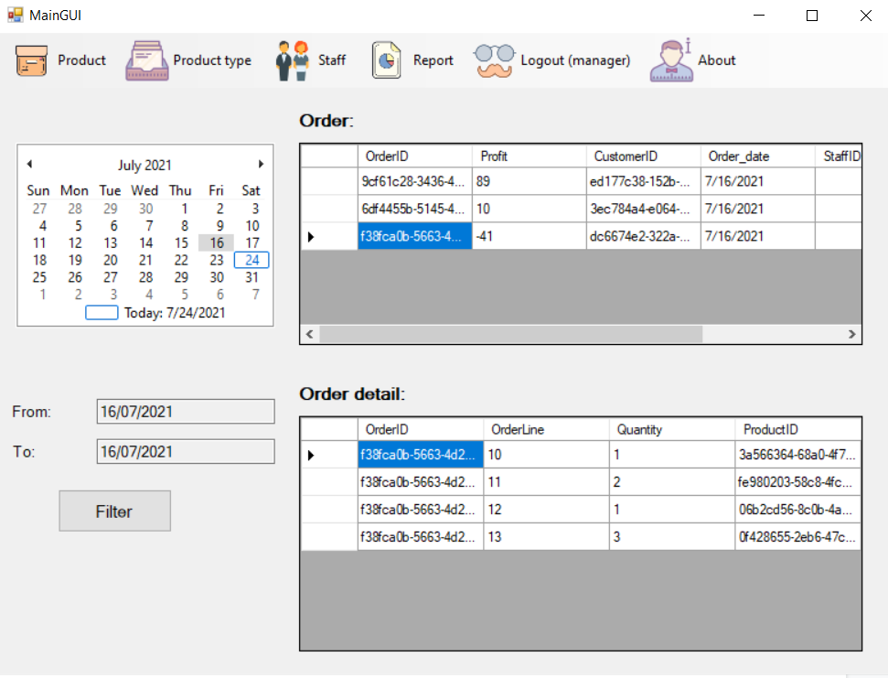

## **5.2. Interface Flow Diagrams**

